Chase Carter

CS-340

Professor Wilson

11/14/2024

3-1 Milestone: Database Indexing and Authentication

1. In Apporto, open the terminal window to access the Linux shell. Upload the Austin Animal Center (AAC) Outcomes data set into MongoDB by importing a CSV file using the appropriate MongoDB import tool.

1. After importing your data set, open the mongo shell. Create a simple index on the key “breed.” Show an example query using this index, and use the explain function to verify that the index will be used.

1. Create a compound index that will improve the performance of queries looking for breeds that have an “outcome_type” of “Transfer.” Show an example query using this compound index, and use the explain function to confirm the index will be used.

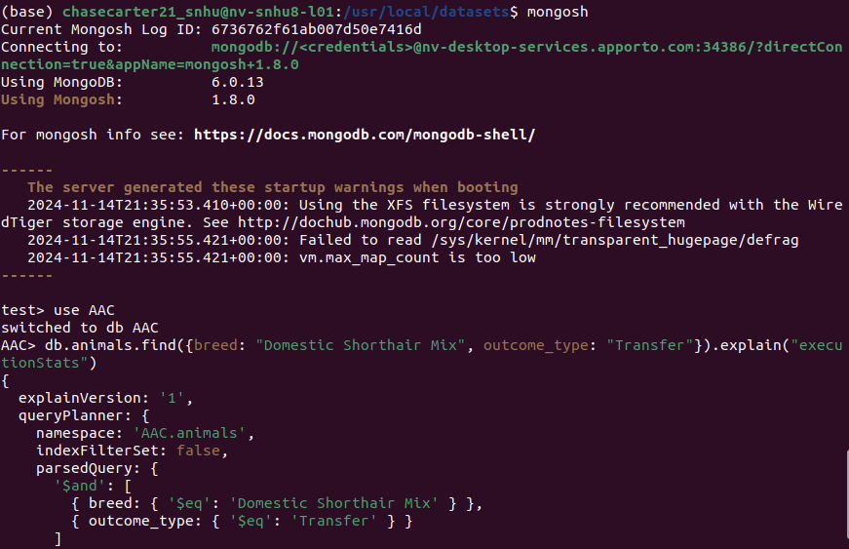

2.1 Create a new user account called “aacuser” for the database AAC in the mongo shell. Refer to steps 6–7 of the MongoDB Manual Enable Access Control tutorial for help with this task.

2.2 